Authors :
- Ronan Le Boulch
- Benjamin Roy
- Remi Gribonval

Getting Started with the Matching Pursuit Toolkit

Summary :
Read this document to learn how to start using MPTK for any operating system.

LAYOUT
1.Introduction 3
1.1.Learning about MPTK 3
1.2.Reading this document 3
2.MPTK for Windows 5
2.1.Downloading MPTK 5
2.2.Installing MPTK 5
2.3.Configuring the path 6
3.MPTK for Linux 8
3.1.Downloading MPTK 8
3.2.Obtaining additional required packages 8
3.3.Installing MPTK 8
3.4.Configuring the path 8
4.MPTK for Mac OS 10
4.1.Downloading MPTK 10
4.2.Obtaining additional required packages 10
4.3.Installing MPTK 10
4.4.Configuring the path 11
5.MPTK from within Matlab 13
5.1.Getting Started 13
5.2.Getting the environment information 13
5.3.Reading a signal 14
5.4.Reading a dictionary 14
5.5.Decomposing a signal 14
5.6.Plotting a book 14
5.7.Reconstructing a signal 14
6.MPTK command line utilities 15
7.Help, contact and forums 16
8.Source installation 17

- Introduction

Learning about MPTK
The Matching Pursuit Tool Kit (MPTK) provides a fast implementation of the Matching Pursuit algorithm for the sparse decomposition of multichannel signals such as audio signals. It comprises a library, standalone utilities and Matlab scripts.

MPTK provides an implementation of Matching Pursuit which is:

- FAST: e.g., extract 1.5 million atoms from a 1 hour long, 16kHz audio signal (15dB extracted) in 0.25x real time on a Pentium IV@2.4GHz, out of a dictionary of 178M Gabor atoms. Such incredible speed makes it possible to process "real world" signals.
- FLEXIBLE: multi-channel, various signal input formats, flexible syntax to describe the dictionaries => reproducible results, cleaner experiments.
- OPEN: modular architecture => add your own atoms ! Free distribution under the GPL.

MPTK is mainly developed and maintained within the METISS Research Group (http://www.irisa.fr/metiss/) on audio signal processing, at the INRIA Research Institute (http://www.irisa.fr or http://www.inria.fr/rennes) in Rennes, France.

Reading this document
This document describes the basic principles about how to download, install and use the Matching Pursuit Tool Kit. It is divided into two major sections :
- Downloading and installing MPTK depending on the system OS
- Understanding the basic usage of MPTK with command line tools
- Understanding the basic usage of MPTK within Matlab

If you need more specific details about any part of this Getting Started document, please refer to the following chapters of the User manual document :
- Chapter 3 for how to pre-build, build and install MPTK from the source files
- Chapter 4 for how to use MPTK with command line tools
- Chapter 5 for how to use MPTK within Matlab

The User manual document can be downloaded here :
- https://gforge.inria.fr/docman/?group_id=36

Part I : Installing MPTK
- MPTK for Windows

Downloading MPTK
The latest version of MPTK is available at (https://gforge.inria.fr/frs/?group_id=36). Depending on the processor architecture of your computer, you will have to download either the 32 bits package or the 64 bits package:
- For Windows 32 bits : “MPTK-binary-v.v.v-i386-Windows.exe”
- For Windows 64 bits : “MPTK-binary-v.v.v-x86_64-Windows.exe”

Hint : To find the processor architecture of your computer:
- Open a terminal command using :
  - Start → All Programs → Accessories → Command Prompt
- Use the following command : echo %PROCESSOR_ARCHITECTURE%
→ If the answer is “x86” then your OS is 32 bits
→ If the answer is “AMD64” then your OS is 64 bits

Installing MPTK
When double clicking the executable “MPTK-binary-v.v.v.-(i386/x86_64)-Windows.exe”:
- Accept the terms of the licence agreement
- Select the path folder where to install MPTK (we'll call it <path_to_MPTK>)
  - We suggest to use the default folder : “C:\Program Files\MPTK”
- Finish the installation

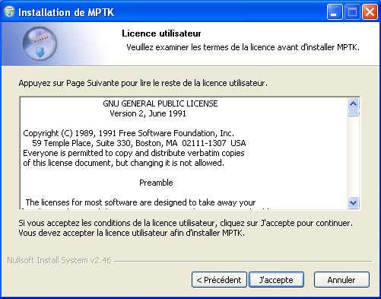Illustration 2: Licence agreement
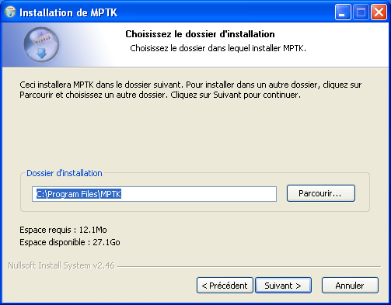Illustration 1: Path folder selection

Configuring the path
An environment variable called MPTK_CONFIG_FILENAME needs to be set, either temporarily, or permanently, with the path of the “path.xml” file located in the “<path_to_MPTK>/mptk” directory. This file defines the environment paths that MPTK needs to work correctly.

Temporary path configuration
Here is the way to temporarily configure the MPTK_CONFIG_FILENAME environment variable. Warning : This is a temporary setting and it needs to be done at each reset of the computer.

- Open a terminal command using :
  - Start → All Programs → Accessories → Command Prompt

- Use the command : set MPTK_CONFIG_FILENAME =<path_to_MPTK>/mptk/path.xml
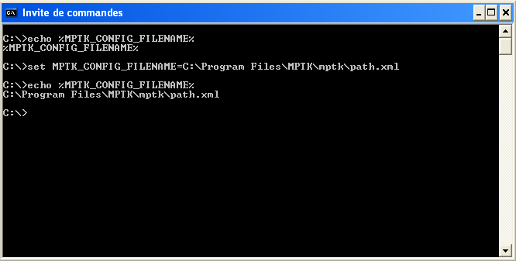Illustration 3: Filled command prompt

Permanent path configuration
Here is the way to permanently configure the MPTK_CONFIG_FILENAME environment variable
- Check if the environment variable is correctly set with : echo %MPTK_CONFIG_FILENAME%
Here is how to permanently configure the MPTK_CONFIG_FILENAME environment variable.

- Open the environment variable configuration panel situated under :
  - Start → Config panel → System → Advanced → Environment variables
  - Add a new user variable with :
    - Name : MPTK_CONFIG_FILENAME
    - Value : <path_to_MPTK>/mptk/path.xml
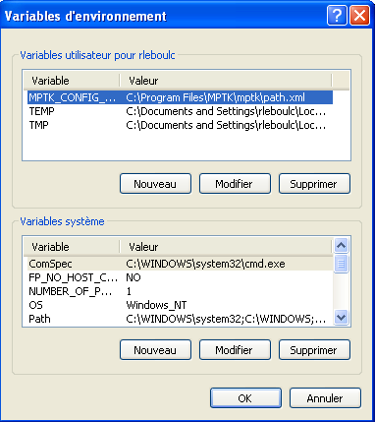Illustration 4: Environment variable configuration

Matlab path configuration
When launching Matlab, the user needs to configure Matlab to work with MPTK:
- Configure the working path either by:
  - Selecting the current folder as “<path_to_MPTK>/mptk/matlab”
  - Adding the working path using addpath(“<path_to_MPTK>/mptk/matlab”)
- MPTK for Linux

Downloading MPTK
The latest version of MPTK is available at (https://gforge.inria.fr/frs/?group_id=36). Depending on the processor architecture of your computer, download either the 32 bits package or the 64 bits package:
- For RedHat, Suse, Fedora, Mandriva
  - 32 bits : “MPTK-binary-v.v.v-i386-Linux.rpm”
  - 64 bits : “MPTK-binary-v.v.v-x86_64-Linux.rpm”
- For Debian, Knoppix, Ubuntu
  - 32 bits : “MPTK-binary-v.v.v-i386-Linux.deb”
  - 64 bits : “MPTK-binary-v.v.v-x86_64-Linux.deb”

Hint : To find the processor architecture of your computer :
- Open a terminal and use the following command : uname -m
→ If the answer is “i386” then your OS is 32 bits
→ If the answer is “x86_64” then your OS is 64 bits

Obtaining additional required packages
Two additional packages are needed. Their installation require administrator privileges on the machine. The “sudo” command may ask you to input administrator password :
- Libsndfile (tested with version 1.0.23) pre compiled library
- FFTW (tested with version 3.2.2) pre compiled library

You can see below some examples about how to download those libraries using terminal:

Ubuntu | Fedora | Mandriva
sudo apt-get install -y -qq libsndfile1-dev  sudo apt-get install -y -qq libfftw3-dev | sudo yum -y -qq install libsndfile-devel  sudo yum -y -qq install fftw-devel  sudo yum -y -qq install fftw-static | sudo smart install -y -qq libsndfile1-dev  sudo smart install -y -qq libfftw3-dev

Installing MPTK
Depending on the type of Linux you have there ares two ways to install the packages :
- for “rpm” package : rpm -ivh MPTK-binary-v.v.v-(i386/x86_64)-Linux.rpm
- for “deb” package : dpkg -i MPTK-binary-v.v.v-(i386/x86_64)-Linux.deb

Configuring the path
An environment variable called MPTK_CONFIG_FILENAME needs to be set, either temporarily, either permanently, with the path of the “path.xml” file located in the “<path_to_MPTK>/mptk” directory. This file defines the environment paths that MPTK needs to work properly.

Temporary path configuration
Here is the way to temporarily configure the MPTK_CONFIG_FILENAME environment variable. Warning : This is a temporary setting and it needs to be done at each reset of the computer.
- With Bash shell :
  - export MPTK_CONFIG_FILENAME="<path_to_MPTK>/mptk/path.xml"
- With C-shell :
  - setenv MPTK_CONFIG_FILENAME "<path_to_MPTK>/mptk/path.xml"
- You can check if the environment variable is correctly set with :
  - echo $MPTK_CONFIG_FILENAME

Permanent path configuration
In order to permanently configure the MPTK_CONFIG_FILENAME environment variable, add the bash shell (or the C-shell) configuration line to the “.bashrc” (or the “.cshrc”) file situated under your home directory.

Matlab path configuration
When launching Matlab, the user needs to configure Matlab to work with MPTK:
- Configure the working path either by:
  - Selecting the current folder as “<path_to_MPTK>/mptk/matlab”
  - Adding the working path using addpath(“<path_to_MPTK>/mptk/matlab”)
- MPTK for Mac OS

Downloading MPTK
The latest version of MPTK is available at (https://gforge.inria.fr/frs/?group_id=36). Depending on the processor architecture of your computer, you will have to download either the 32 bits package or the 64 bits package:
- For Mac 32 bits : “MPTK-binary-v.v.v-i386-Mac.exe”
- For Mac 64 bits : “MPTK-binary-v.v.v-x86_64-Mac.exe”

Hint : To find the processor architecture of your computer :
- Open a terminal and use the following command : uname -m
→ If the answer is “i386” then your OS is 32 bits
→ If the answer is “x86_64” then your OS is 64 bits

Obtaining additional required packages
Two additional packages are needed. Their installation require administrator privileges on the machine. The “sudo” command may ask you to input administrator password :
- Libsndfile (tested with version 1.0.23) pre compiled library
- FFTW (tested with version 3.2.2) pre compiled library

You can see below some examples about how to download those libraries using terminal:

Mac
sudo /opt/local/bin/port install libsndfile +universal
sudo /opt/local/bin/port install fftw-3 +universal

Hint : We suggest to use the “port” command from MacPorts because the command “+universal” allows to retrieve libraries which are compatible with both system architectures (32 bits and 64 bits). The package is available at http://www.macports.org/install.php

Installing MPTK
When double clicking the executable “MPTK-binary-v.v.v.-(i386/x86_64)-Mac.dmg”:
- Accept the terms of the licence agreements
- Accept the path folder where to install MPTK
  - The default and unique folder is : “/usr/local/”
- Finish the installation
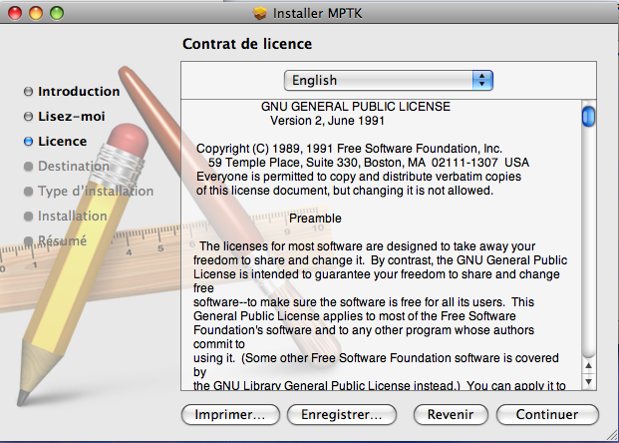Illustration 5: Licence agreement
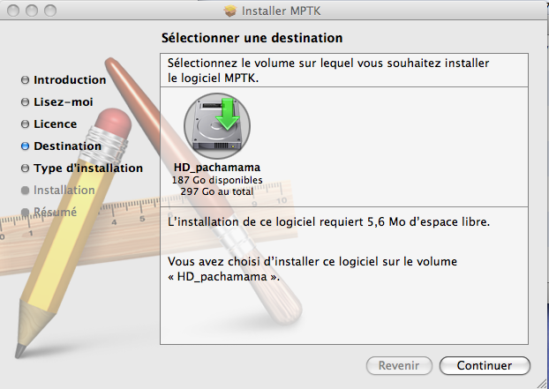Illustration 6: Path folder selection

Configuring the path
An environment variable called MPTK_CONFIG_FILENAME needs to be set, either temporary, either permanently, with the path of the “path.xml” file located in the “<path_to_MPTK>/mptk” directory. This file defines the environment paths that MPTK needs to work properly.

Temporary path configuration
Here is the way to temporary configure the MPTK_CONFIG_FILENAME environment variable. Warning : This is a temporary setting and it needs to be done at each reset of the computer.
- With Bash shell :
  - export MPTK_CONFIG_FILENAME="/usr/local/mptk/path.xml"
- With C-shell :
  - setenv MPTK_CONFIG_FILENAME "/usr/local/mptk/path.xml"
- You can check if the environment variable is correctly set with :
  - echo $MPTK_CONFIG_FILENAME

Permanent path configuration
In order to permanently configure the MPTK_CONFIG_FILENAME environment variable, add the bash shell (or the C-shell) configuration sentence to the “.bashrc” (or the “.cshrc”) file situated under your home directory.

Matlab path configuration
When launching Matlab, the user needs to configure Matlab to work with MPTK:
- Configure the working path either by:
  - Selecting the current folder as “/usr/local/mptk/matlab”
  - Adding the working path using addpath(“/usr/local/mptk/matlab”)

Part II : Using MPTK
- MPTK from within Matlab
In the following, we assume that MPTK has been installed correctly, that the system path configuration has been set and that Matlab is installed.

Getting Started
GettingStarted command is used for a better understanding of MPTK functionalities. This script is divided in two parts. The first part consist on retrieving the environment informations and the available plugins. The second part consist on describing several tutorials about MPTK utilities.

1st part description : Example of available plugins and dictionaries

Here is the list of types of atoms available in MPTK plugins:
- anywave - anywavehilbert
- constant - dirac
- gabor - harmonic
- mclt - mdct
- mdst - nyquist

As well as information on the path where reference files can be found:
- /usr/local/mptk/reference

which can be used to find examples of dictionaries:
dic_anywave.xml dic_constant.xml dic_harmonic.xml
dic_mdst.xml dic_anywave_modifie.xml dic_dirac.xml
dic_mclt.xml dic_nyquist.xml dic_chirp.xml
dic_gabor_two_scales.xml dic_mdct_two_scales.xml dico_test.xml

2nd part description : Description of the tutorials

There are several tutorials on using MPTK4Matlab:
(1): Dictionaries
(2): Books
(3): Running Matching Pursuit Toolkit
(4): Multichannel decompositions (in preparation)
(5): Anywave atoms (in preparation)
(6): Demixing pursuit (in preparation)

Dictionaries : Tutorial explaining how to read (dictread), create (dictwrite) a dictionary description
Books : Tutorial explaining what is a book (storage format for sparse signal representations) and how to read (bookread), save (bookwrite) or plot any book (bookplot, bookover)
Running MPTK : Tutorial explaining the procedure to follow if you want to decompose a signal :
- Read a signal (sigread)
- Read a dictionary (dictread)
- Decompose the signal (mpdecomp)

Getting the environment information
getmptkinfo command is launched under the GettingStarted script, and is used to retrieve the environment datas, such as :
- The plugins atoms names available
- The block parameters needed to correctly define each atom
- The windows names that can be used to through the signal waveform
- The example or default environment paths

>> info = getmptkinfo();

Reading a signal
sigread command reads an imports signal “exampleSignal” of any format supported by libsndfile library to Matlab and gives a matrix “signal” (numSamples x numChans) and the sampling frequency of the read signal “sampleRate”.

>> [signal sampleRate] = sigread(mptkInfo.path.exampleSignal);

Reading a dictionary
dictread command imports a dictionary description “defaultDict” to Matlab and gives a dictionary description with the following structure :
dict.block{i} = block where, for example
block.type = 'dirac'

>> dict = dictread(mptkInfo.path.defaultDict);

Decomposing a signal
mpdecomp command decompose a signal “Signal” using its sampling frequency “sampleRate”, a dictionary structure “dict” performing “numIter” iterations and gives the resulting decomposition “book”, the “residual” obtained after the iterations and “decay”, a vector with the energy of the residual after each iteration.

>> [book residual decay] = mpdecomp(signal,sampleRate,dict,numIter);

Plotting a book
bookover plots the given “book” over a STFT spectrogram of the given ”Signal” for channel “numChan” (or 1 for default). The book and/or the signal can be given as filenames (WAV format for the signal.

>> figure(5);bookover(book,signal);

Reconstructing a signal
mprecons reconstructs the signal from the given “book”.

>> sigrec = mprecons(book);

For further information on how to use MPTK Matlab functionalities please refer to the Chapter 5 of the Usermanual documentation situated under the gforge website (https://gforge.inria.fr/docman/?group_id=36) or under the documentation directory (MPTK UserManual).

- MPTK command line utilities
Here is a simple example on how to use MPTK with terminal commands :
----------------------------------------------------------------------------------------------------------
mpd command iterates Matching Pursuit on signal “sndFILE.wav” with dictionary
“dictFILE.xml” and gives the resulting book “bookFILE.bin” (and an optional residual
signal) after N iterations or after reaching the signal-to-residual ratio SNR.
----------------------------------------------------------------------------------------------------------
$ mpd -s 10 -R 10 -C ~/bar/mptk/path.xml -D ~/bar/mptk/reference/dictionary/dictFILE.xml ~/bar/mptk/reference/sndFILE.wav ~/bar/mptk/reference/bookFILE.bin

---------------------------------------------------------------------------------------------------
mpr commands rebuilds a signal reconsFile.wav from the atoms contained in
the book file “bookFile.bin”. An optional residual “residFile.wav” can be added.
---------------------------------------------------------------------------------------------------
$ mpr -C ~/bar/mptk/path.xml ~/bar/mptk/reference/bookFile.bin ~/bar/mptk/reference/reconsFile.wav ~/bar/mptk/reference/residFile.wav

----------------------------------------------------------------------------------------------------------------
mpf commands filters the atoms contained in “bookFile.bin” (or stdin), stores those which
satisfy the indicated properties in “bookYes.bin” (or stdout) and the others in “bookNo.bin”.
----------------------------------------------------------------------------------------------------------------
$ mpf -C ~/bar/mptk/path.xml --Freq=[0:110] --len=[0:256] ~/bar/mptk/reference/bookFile.bin
/tmp/bookYes.bin /tmp/bookNo.bin

For further information on how to use MPTK terminal functionalities please refer to the Chapter 4 of the Usermanual documentation situated under the gforge website (https://gforge.inria.fr/docman/?group_id=36) or under the documentation directory (MPTK UserManual).
- Help, contact and forums

If you need help with the software:
- Check if a more recent release fixes your problem (https://gforge.inria.fr/frs/?group_id=36)
- Check if somebody else has had a samilar problem and if a fix exist on the help forum (https://gforge.inria.fr/forum/forum.php?forum_id=109)
- If not, post a message on the help forum

If you need documentation about the software:
Some articles exposing scientific results related to MPTK are available in PDF format through the following page (https://gforge.inria.fr/docman/?group_id=36)

If you want specific information :
You can write to us to matching.pursuit@irisa.fr.

Request for help sent to this address won't be answered. Please use the Help forum instead.

Thank you for your interest in The Matching Pursuit ToolKit !

- Source installation
The source installation archive file (https://gforge.inria.fr/frs/?group_id=36) is available under gforge website . This kind of installation is recommended for :
- Whoever have problems installing the binary files
- Whoever wants to help developing MPTK and/or adding new functionalities to MPTK
For further information on how to pre-build with cmake, build and install MPTK from the source files, please refer to the chapter 3 of the Usermanual documentation situated under gforge website (https://gforge.inria.fr/docman/?group_id=36) or under the documentation directory (MPTK UserManual).

